ADJUSTING THE HEIGHT OF ALL FRAME TYPES
In order to ensure the frame is the correct height for the user, it will need to be adjusted accordingly (your frame will either have a horse shoe clip or spring pin and can be adjusted as shown in Fig 1 or 2).
WARNING: When using a non-wheeled walking frame the legs should be set to the same height. When adjusting frames fitted with wheels it is advisable to set the rear legs one position higher than the front wheels. This is to compensate for the increased height of the wheels at the front which can adversely affect the stability of the frame. and the slope of the handles.
Horseshoe Clip Adjustment
- Remove the clip by grasping it between thumb and forefinger and pulling out.
- Slide the leg in or out to the ideal position.
- Push the clip back firmly into the hole.
- Check the clip is fully located before use.
- Repeat for other legs.
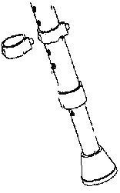
FIG. 1
Spring Pin Adjustment
- Press the two buttons in.
- Push the leg as if to shorten.
- Turn the leg slightly.
- Extend the leg to the required position, turn and re-locate buttons into the appropriate holes.
- Check pins are fully located before use.
- Repeat for other legs.
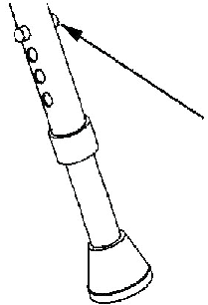
FIG. 2
USING ALL FRAME TYPES
Walking
- Place the frame one step ahead and walk towards it using the affected leg first, followed by the other leg, which should then step through. Do not walk too far into the frame area.
- When steady, lift the frame and place a short distance in front (When using front wheeled frames, the rear legs should be lifted and wheeled forward as opposed to it being used as a wheeled rollator.) and repeat this process (Fig 3).
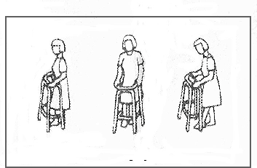
FIG. 3
Getting into and out of Chairs
- Position the frame in front of the chair.
- Get up by pushing on the arms of the chair and transfer hand to frame when fully standing.
- To sit down, using the frame, turn round in front of the chair and feel the chair behind you with your legs.
- Place hands gently on the chair arms, bend slightly forward and sit down gently (Fig4).
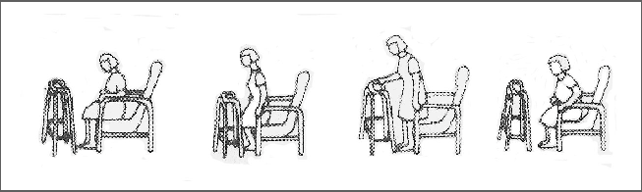
FIG. 4
CONTINUED

